Maths
This calendar shows the production of flour bags in the mill.

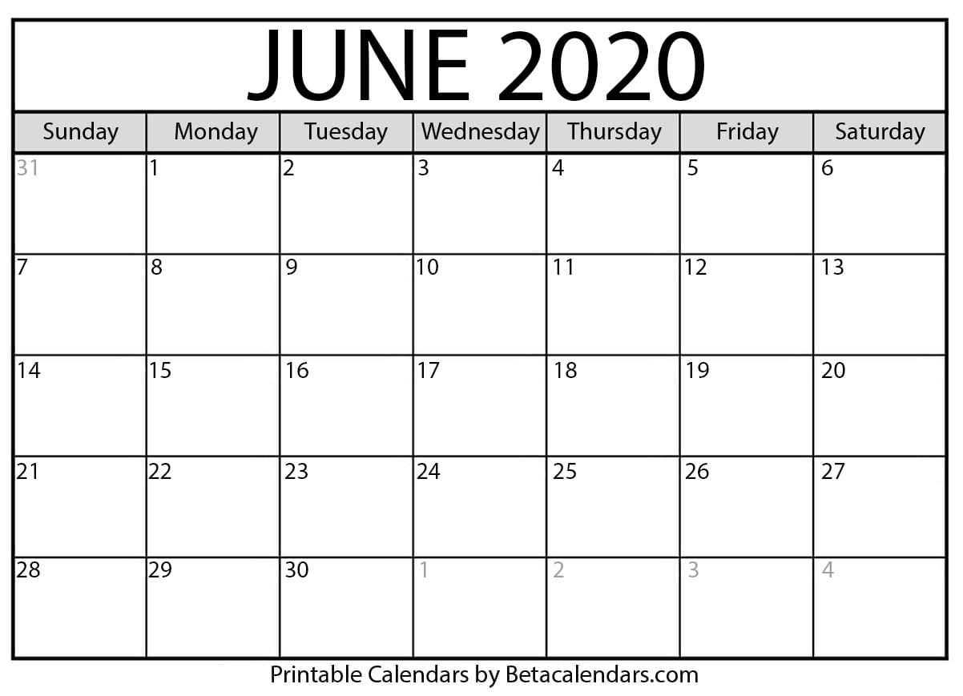
Read the calendar and answer the questions.
2
5
4
3
1
2
7
3

- How many bags of flour were produced in the mill on Monday 1 of June 2020 ?

Monday 1 : …………

- How many bags of flour were produced on Wednesday 3 of June 2020 ?

Wednesday 3 : ………...
- How many bags of flour do we get if we add the production of Monday 1 and Wednesday 3 ?

Monday 1 ………. + Wednesday 3 ……… = ………….

- On which day did the mill produce no flour at all ?

…………………………………………………………..

- On which day did the mill produce 7 bags of flour ?

…………………………………………………………..

- 7 + 3 = ………………

- On which day did the mill produce 3 bags of flour ?

……………………………………………………….

