Maths
Activity 1.
The Pussy in Boots has written the production of the wind mill on his note book. Can you help him, to complete this calendar ?
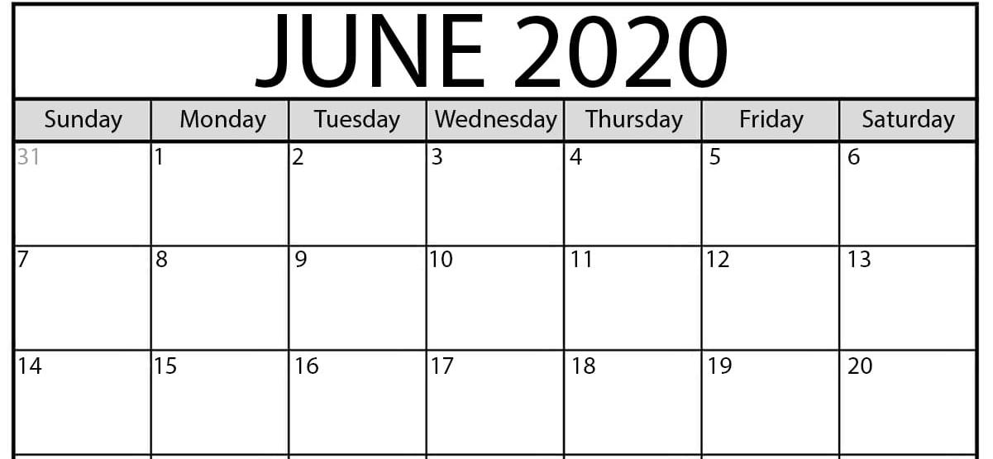
Production of the wind mill :
Monday 8 of June – 24 bags of flour
Wednesday 3 of June – 15 bags of flour
Tuesday 2 of June - 13 bags of flour
Thursday 11 of June – 14 bags of flour
Monday 1 of June – 22 bags of flour
Tuesday 16 of June – 37 bags
Friday 19 of June- 44 bags

Activity 2.
- On Tuesday 4 the mill produced 4 bags more than on Wednesday 3. How many bags were produced on Tuesday 4 ?

Put your answer in the calendar.

- On Friday 5 the mill produced 32 + 24 bags of flour. How many bags were produced on the Friday 5 ?

Put your answer in the calendar.

- On Wednesday 17 the mill produced 30 bags more than on the Tuesday 16. How many bags were produced on Wednesday 17 ?

Put your answer in the calendar.

Activity 3 .
Read the calendar and awnser the questions :
On which day was the production the biggest ? ………………………………………
How many bags were produced ? …………………………
On which day was the production the smallest ? …………………………………….
How many bags were produced ? …………………………

